# Robo Jam

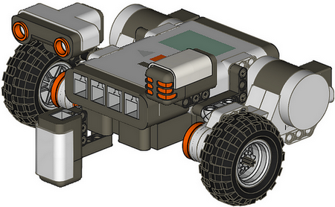

School of Computer Science, University of Lincoln

University of Lincoln Computing Society

Contents

Welcome 3

Meet the NXT 4

Day 1 Tutorials 5

Tutorial 1 - Movement 5

Task 1 - Straight Line Movement 5

Task 2 – Adding Sound 6

Task 3 - Figure of 8 6

Tutorial 2 - Sound Sensor 7

Build Instructions 7

Task 1 – Hearing Sounds 8

Tutorial 3 - Touch Sensor 9

Build Instructions 9

Task 1 - Change Direction When You Hit Obstacle 10

Tutorial 4 - Ultrasonic Sensor 11

Build Instructions 11

Task 1 – Obstacle Avoidance 12

Task 2 – Random Direction 13

Tutorial 5 - Light Sensor 14

Build Instructions 14

Task 1 – Line Following 15

# Welcome

Dear Participants,

I would like to welcome you to the Lincoln School of Computer Science Robo-Jam where you will have the chance to program your own robots.

The aim of the Robo-Jam is to improve student engagement and to enrich student experience. The Robo-Jam is intended to be a regular activity in the future. It is also envisaged that the designed tasks will be adopted for future use in outreach activities in high school, open days, etc.

This will be the first time the Robo-Jam has been run since the project started at the beginning of June. With this in mind we are targeting computing students from different

The event is split up into two consecutive days, one day will be used for training and the other will be used for a small competition. During this event we will be making use of the Lego Mindstroms NXT 1.0 kit (NXTs), allowing you to make use of a range of different sensors and motors. The days will start around 9am till 5pm with a lunch break in-between, you are welcome to schedule your day as you see fit.

Day 1 will consist of a variety of tutorials that will help you understand how to program the NXT. You will start of using the NXT-G software and finish up using C# to control the NXT.

Day 2 will consist of a variety of challenges, for each challenge you will gain points depending on how well you do. At the end of the day the group with the most points will win a prize.

This event has been funded by the Lincoln School of Computer Science, LNCD (an educational research group), and the University of Lincoln Computing Society.

# Meet the NXT

Figures 1 and 2 below show the layout of both the Lego NXT Brick and the Lego NXT-G programming environment.

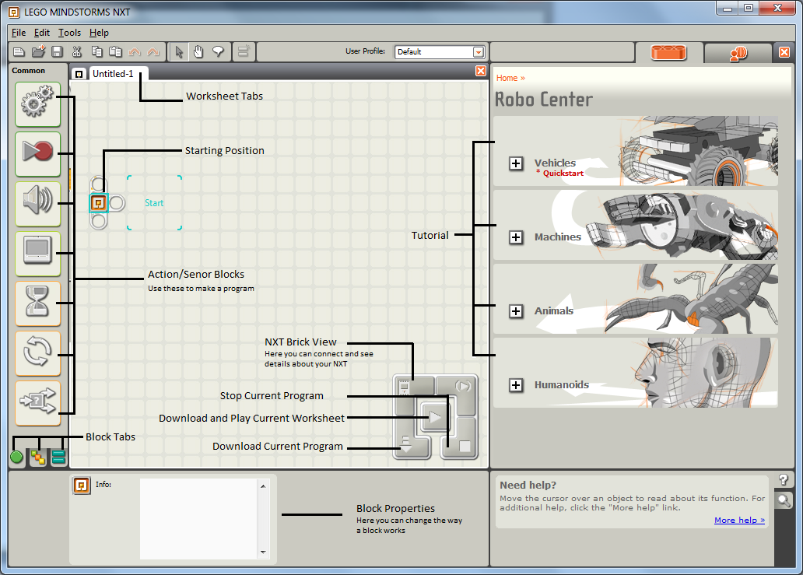

Figure : NXT-G Environment

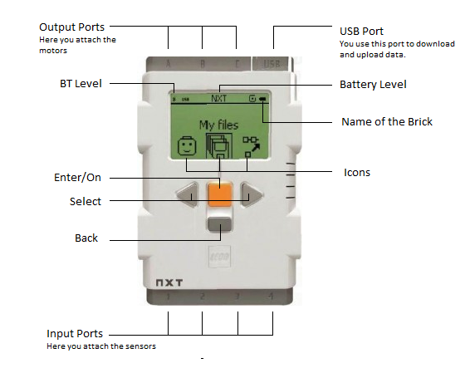

Figure : NXT Brick

# Day 1 Tutorials

## Tutorial 1 - Movement

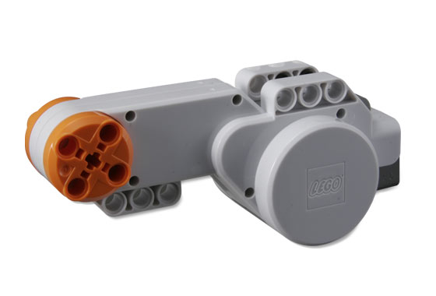

Figure 3 – NXT Motor

The NXT comes with a set of motors (Figure 3) that plug into ports **A**, **B** and **C**. These motors can be used to make your robot move around the room or to give it moving parts e.g. an arm. The motors allow you to have precision control over their speed, rotation and direction.

### Task 1 - Straight Line Movement

Here we will make our NXT move in a straight line.

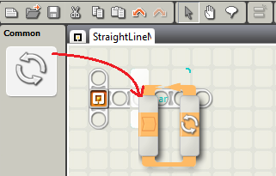

Figure 4 – Adding Loop Block

1. Drag the ‘Loop’ block into the work area and connect it to the ‘Starting Point’ (Figure 4).

Drag the ‘Move’ block into the ‘Loop’ block (Figure 5). Make sure the ‘Move’ block settings match Figure 6.

If everything went well your NXT should move forward three rotations or the wheels, stop, and then repeat the task continuously.

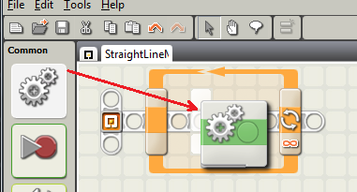

Figure 5 – Adding Move Block

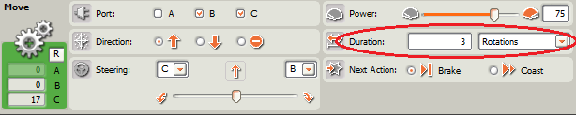

Figure 6 – Move Block Properties

#### Task 2 – Move in a Square

Now that we can make our NXT move forward we can look at how to make it turn.

Following on from ‘Task 1’:

1. Add another ‘Move’ block into the loop (Figure 7).
2. You will need to change the settings of one of the ‘Move’ blocks to match Figure 8.

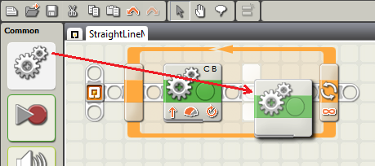

Figure 7 – Adding Move Block

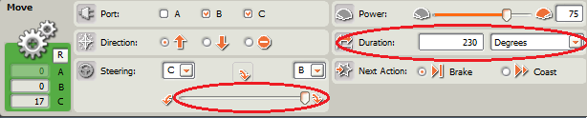

Figure 8 – Move Block Properties

1. You will need to make this loop repeat four times, this can be done by changing the Control type to ‘Count’ and the setting the UntilCount to ‘4’ (Figure 9).

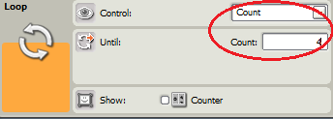

Figure 9 – Loop Block Properties

### Task 2 – Adding Sound

The NXT has an inbuilt speaker that allows you to play tones, songs and sounds.

Following on from ‘Task 2’

1. Drag the ‘Sound’ block into the work area after the loop. The program will play the sound when is has finished (Figure 11). You can change what sound is played in the properties (Figure 10).

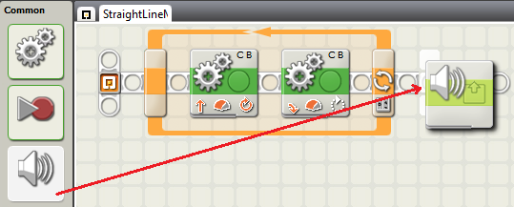

Figure 10 – Adding Sound Block

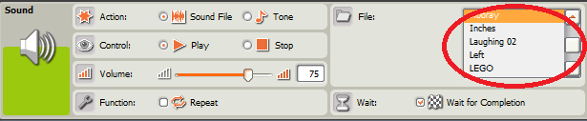

Figure 11 – Sound Block Properties

### Task 3 - Figure of 8

Using the skills you have just learnt see how many of the following figure of 8s you can make the NXT move in.

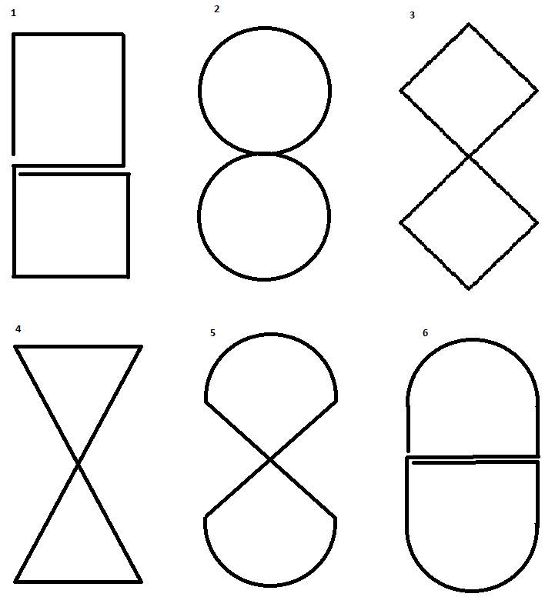

Figure 12 – Figure of 8s

## Tutorial 2 - Sound Sensor

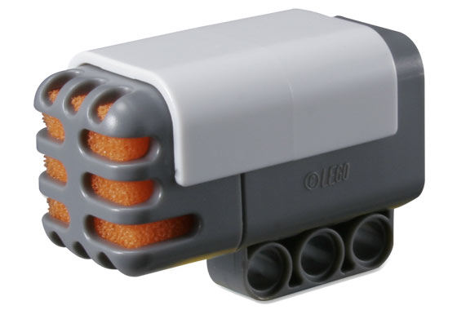

Figure 13 – Sound Sensor

The NXT comes with a ‘Sound’ sensor (Figure 13), this is basically a microphone. This sensor is capable of hearing all sounds the human ear can hear but also some sounds outside of the audible spectrum.

The sensor returns a value between 0 – 100%, 0% being silent and 100% being the loudest.

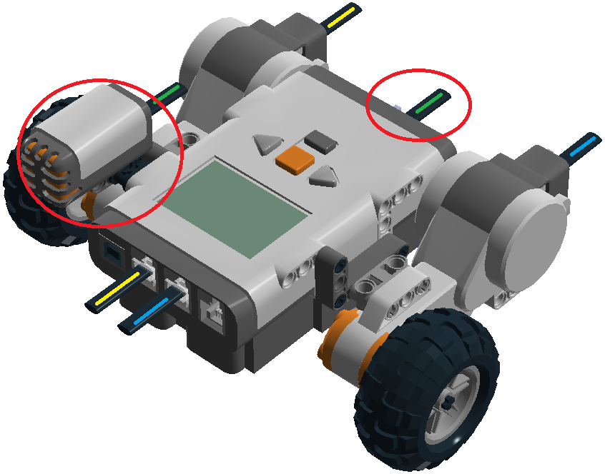

Figure 14: Sound Sensor Build Instructions

### Build Instructions

**Note: Make sure you connect the sensor to Port 2!**

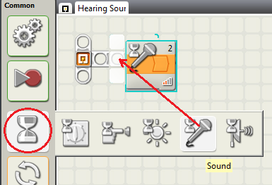

Figure 15 – Adding Sound Block

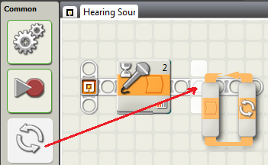

Figure 16 – Adding Loop Block

## Task 1 – Hearing Sounds

Here we are going to give the NXT the ability to hear sounds.

1. Start a new project. You will need to add a wait cue; this will halt the program until the condition is fulfilled (in this case when a sound is heard). Open the ‘Wait’ menu and drag the ‘Sound’ block into the work sheet (Figure 15).
2. Add a ‘Loop’ block after the Sound block from ‘Step 1’ (Figure 16).

Make sure the settings match Figure 17.

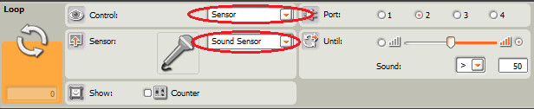

Figure 17 – Sound Block Properties

1. Add a sound wait cue inside the ‘Loop’ block. This will make sure the motor only moves when there is no sound (Figure 18).

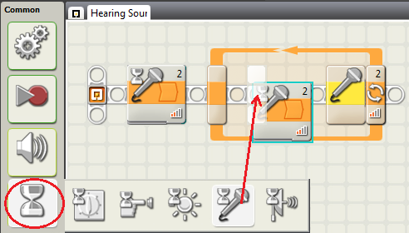

Figure 18 – Wait -> Sound Block

1. Add a ‘Move’ block after the second ‘Sound’ block (Figure 19). Make sure the settings match Figure 20.

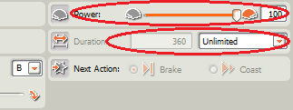

Figure 20 – Move Block Properties

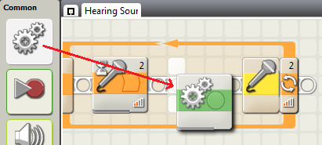

Figure 19 - Adding Move Block

If everything went well your NXT should wait to hear a sound, and then continuously move forward until it hears another sound.

## Tutorial 3 - Touch Sensor

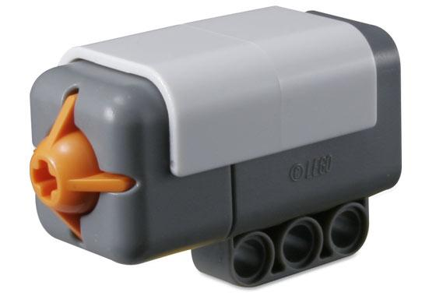

Figure 21 – Touch Sensor

The NXT comes with a Touch sensor (Figure 21) for you to make use of. The sensor has two different states, pressed and released. This could be used to detect when the NXT has bumped into an obstacle.

### Build Instructions

**Note: Make sure you connect the sensor to Port 1!**

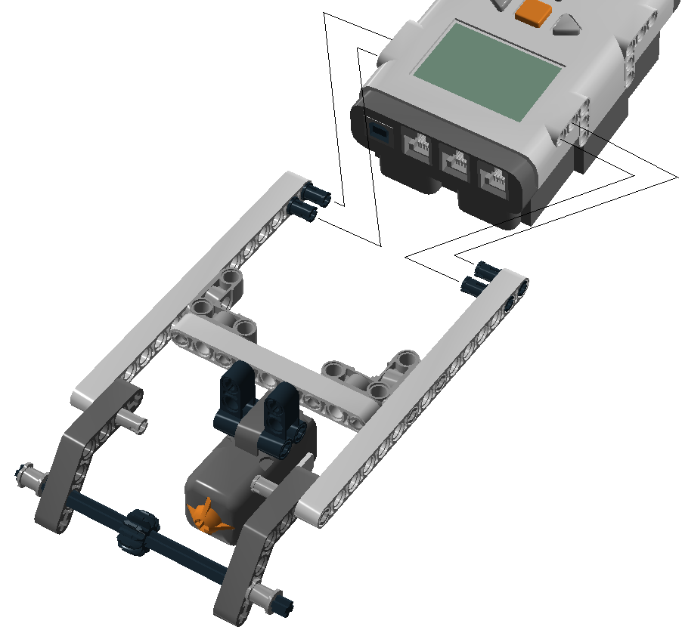

Figure 22: Touch Sensor Build instructions

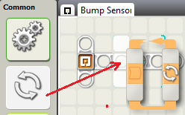

Figure 23 – Adding Loop Block

### Task 1 - Change Direction When You Hit Obstacle

1. Start a new project. Add the ‘Loop’ block to the start position in the work sheet (Figure 23).
2. Drag a ‘Switch’ block into the ‘Loop’ block placed in Step 1 (Figure 24).

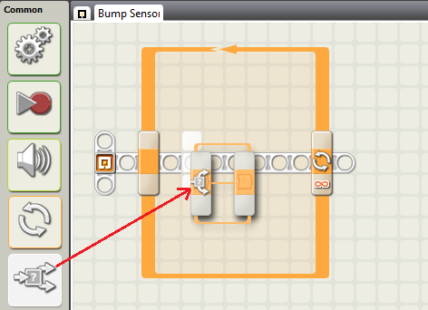

Figure 24 – Adding Switch Block

1. Add a ‘Move’ block to the upper section of the ‘Switch’ block (Figure 26), this instruction will only be performed when the switch is pressed. Make sure the setting match Figure 25.

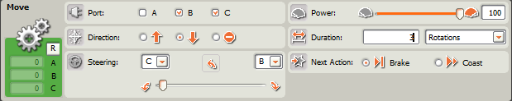

Figure 25 – Move Block Properties

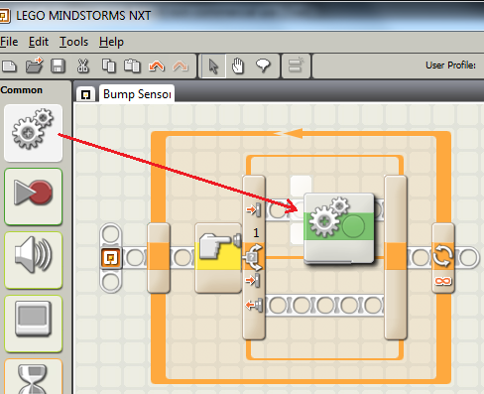

Figure 26 - Adding Move Block

1. Add a ‘Move block to the lower section of the ‘Switch’ block (Figure 28), this instruction will run when the button is not pressed. Make sure the settings match Figure 29.

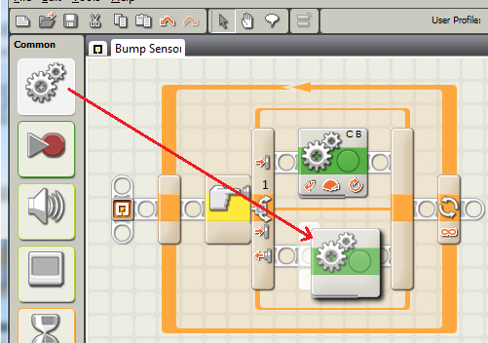

Figure 28 - Adding Move Block

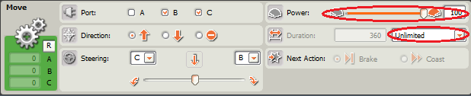

Figure 29 – Move Block Properties

If everything when well, your NXT should reverse and turn when it hits and obstacle, then repeat the task continuously.

## http://bricker.ru/images/sets/9846_brickset.jpgTutorial 4 - Ultrasonic Sensor

Figure 29 – Ultrasonic Sensor

The NXT comes with an Ultrasonic sensor (Figure 29); this gives your NXT the ability to see. The sensor will be able to detect object in front of it for up to 255cm.

### Build Instructions

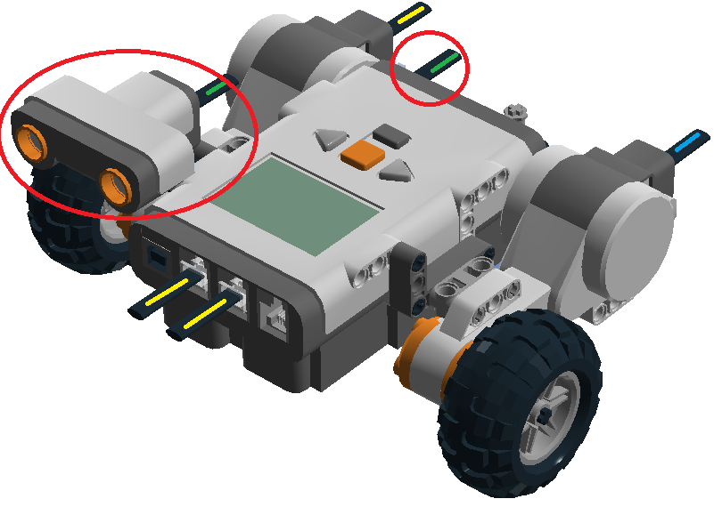

Figure : Sonar Sensor Build Instructions

**Note: Make sure you connect the sensor to Port 4!**

### Task 1 – Obstacle Avoidance

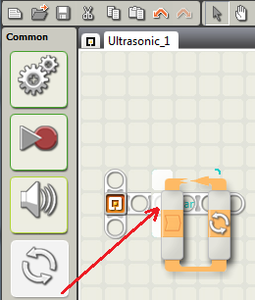

Figure – Adding Loop Block

This program will make the robot stop when it detects an object in front of it. .

1. Start a new project. Add a ‘Loop’ block to the start position in the work sheet (Figure 31).
2. Add a ‘Switch’ block into the ‘Loop’ block placed in Step 1 (Figure 32). You will need to change the sensor type to ‘Ultrasonic Sensor’ (Figure 33).

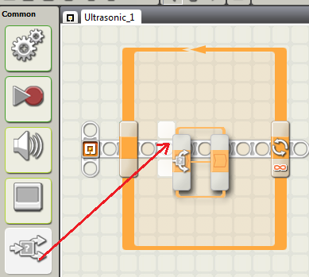

Figure 32 – Adding Switch Block

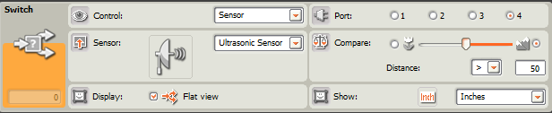

Figure 33 – Switch Block Properties

1. Add a ‘Move’ block to the upper section of the ‘Switch’ block (Figure 34). Make sure the settings match Figure 25.

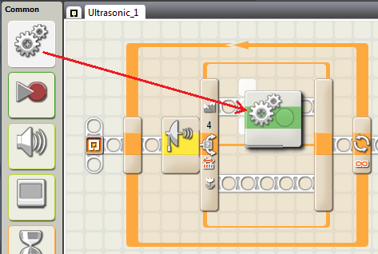

Figure 34 - Adding Move Block

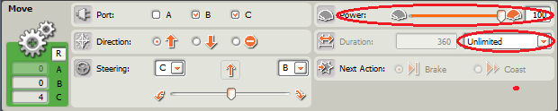

Figure 35 – Move Block Properties

1. Add a ‘Move’ block to the lower section of the ‘Switch’ block (Figure 36). Make sure the setting match Figure 37.

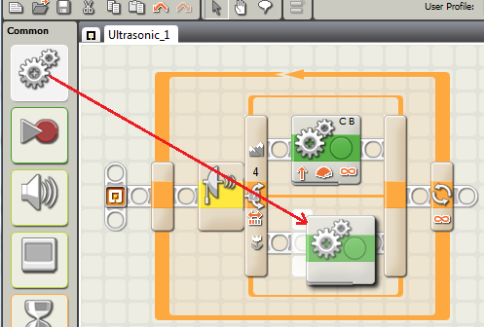

Figure 36 - Adding Move Block

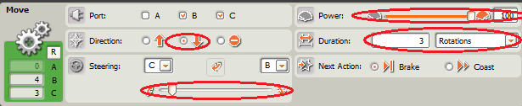

Figure 37 - Move Block Properties

### Task 2 – Random Direction

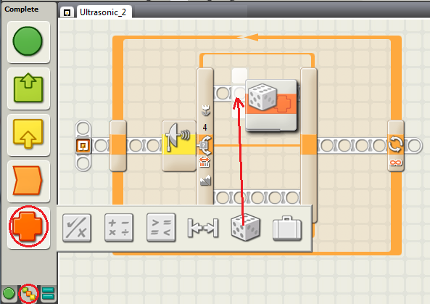

Figure – Adding Random Block

This program will be built on Task 1, however, this time your NXT will pick a random direction when it detects an object, then move.

1. Repeat steps 1-3 from Task 1

4. Drag a ‘Random’ block into the upper section of the Ultrasonic Switch block placed in Task 1 – Step 2 (Figure 38).

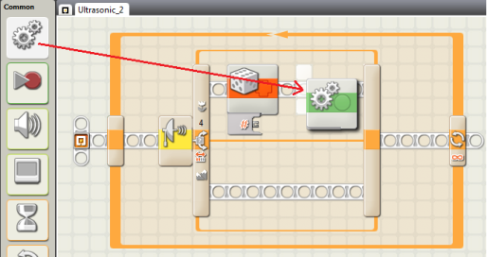

Figure 39 - Adding Move Block

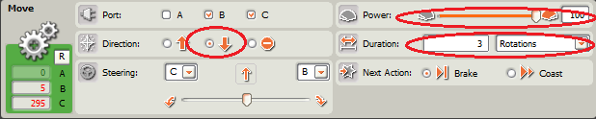

Figure 40 – Move Block Properties

Drag a ‘Move’ block into the upper section of the ‘Switch’ block, after the ‘Random’ block (Figure 39). Make sure the settings match Figure 40.

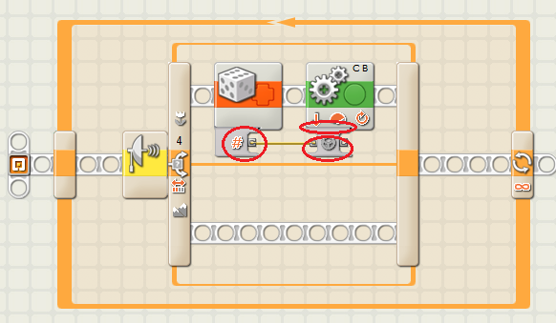

Figure 41 – Connecting Plugs

5. Connect the ‘Number’ of the ‘Random’ block to the ‘Steering’ plug of the ‘Move’ block. To connect plugs just simply click one, and then click another. To disconnect a Wire from a plug, click on the plug (Figure 41).

6. Drag a ‘Move’ block to the lower section of the ‘Switch’ block (Figure 42). Make sure the settings match Figure 43.

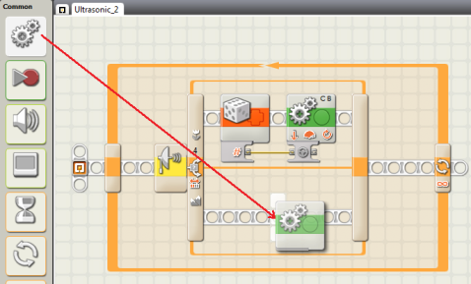

Figure 42 - Adding Move Block

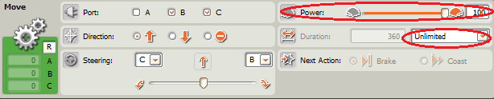

Figure 43 – Move Block Properties

If everything went well, your NXT should drive round the room until it detects an obstacle. Once and obstacle is detected the NXT will reverse and turn in a random direction then repeat the task continuously.

## Tutorial 5 - Light Sensor

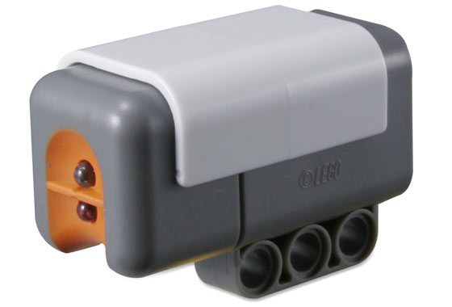

Figure – Light Sensor

The NXT comes with a Light sensor (Figure 44). This sensor is can distinguish between light and dark. The sensor is also capable of generating light; this could be used to detect colour shade in poor lighting conditions.

### Build Instructions

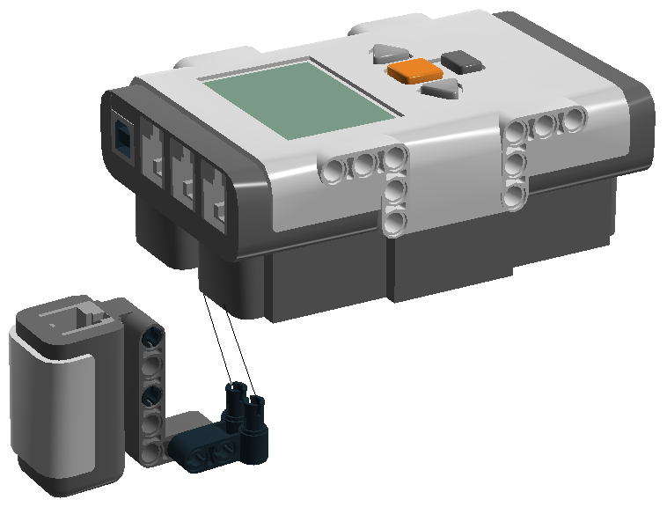

Figure : Light Sensor Build Instructions

**Note: Make sure you connect the sensor to Port 3!**

### Task 1 – Line Following

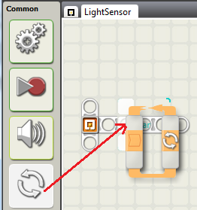

Figure – Adding Loop Block

1. Start a new project. Add a ‘Loop’ block to the start of your program (Figure 46).
2. Place a ‘Switch’ block inside the ‘Loop’ placed in Step 1 (Figure 47). Make sure the settings match Figure 48.

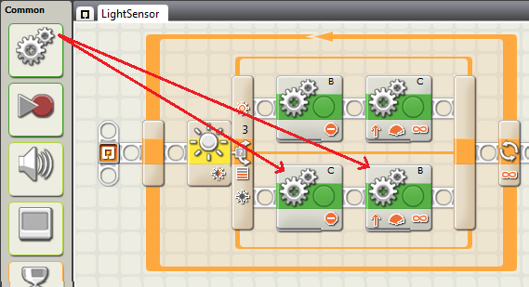

Figure 50 – Adding Two Move Blocks

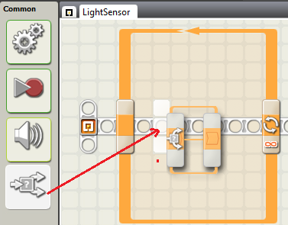

Figure 47 – Adding Switch Block

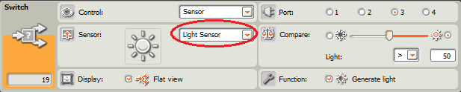

Figure 48 – Switch Block Properties

1. Place two ‘Move’ blocks in upper section of the ‘Switch’ block. One ‘Move’ block will need to stop Motor B, and the other to make Motor C go forward (Figure 49).

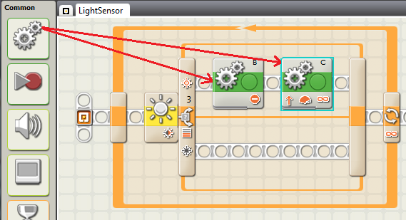

Figure 49 – Adding Two Move Blocks

1. Place two ‘Move’ blocks in lower section of the ‘Switch’ block. One ‘Move’ block will need to stop Motor C, and the other to make Motor B go forward (Figure 50).

If everything went well your NXT will be able to follow the line supplied in your pack.

Congratulations!

You have finished all the tutorials on how to the use the NXT-G software to program your NXT.

You are now ready to move onto programming the NXT in C#.